Liquid Inoculant Development
Research Summary II

In the past year we have completed many projects that further the development and evaluation of liquid inoculants. First, we evaluated the performance of the G5 liquid inoculant (see the first research summary we sent to you for details on its development) in relation to other inoculant products. We then completed a long-term shelf life test of many different liquid formulations. We also performed several tests that address other aspects of the production and performance of liquid inoculants including evaluating glycerol based media and measuring the effects of aeration, pH control and other additives on cell growth and survival.

Performance of Liquid Inoculant Formulations.

Survival of Bradyrhizobium and Rhizobium after Application to Seed. We found earlier that we could correlate (r values ranging from 0.77 to 0.86) the survival of cells applied to seed and stored at 25 C and 66 % relative humidity with soybean nodulation and dry matter production in potted soils that were subjected to drought and temperature stress. We used this laboratory assay (see Appendix 3-1 and 3-6 for methods) to evaluate the capability of 17 commercial inoculant formulations to support rhizobia or bradyrhizobia survival after inoculation.

Table 1 (all tables and figures follow this text presentation) shows the results of this laboratory assay. Only two of the inoculants sent to us by collaborators (sample numbers 11 and 28) supported higher numbers of viable cells on seed 48 h after inoculation than the G5 liquid formulation with B. japonicum strain SEMIA 5019 (mean of four assays – most recent assay of G5 had 2.3 X 10⁶ cells/seed survive). Sample 28 is a commercial liquid formulation producing consistently high survival rates performance. Several inoculants had no detectable or very low numbers of viable cells at the time of the assay and consequentially few cells survived 48 h after inoculation. Other inoculant formulations which had more than 10⁹ viable cells at inoculation (numbers 1, 19, 25) supported populations on the seed 48 h after inoculation that were at least one log lower than the G5 formulation. Results of this assay show a wide variation in the ability of inoculant formulations to support cell survival on seed.

There was no correlation between cell survival in the laboratory assay and the response to inoculation in the field by the commercial inoculants relative to the inoculation response obtained with G5. Small sample size and other factors affecting the response to inoculation in the field (e.g. indigenous B. japonicum populations or yield potential) may have masked any relationship.

Results of this assay showed that the G5 formulation with SEMIA 5019 and other well formulated liquid inoculants can support cell survival after inoculation better than most of the commercial solid carrier formulations made available to us.

Response to Inoculation with the G5 Liquid Inoculant in Multi-Location Field Trials. Our goal was to determine whether the G5 liquid inoculant had field performance characteristics equivalent or better than local products being sold to farmers around the world. Collaborators from sixteen countries agreed to conduct trials (see Appendix 1 for details). A minimum set of critical treatments was included in all trials 1) uninoculated, 2) inoculated with G5, 3) inoculated with a local product. Some collaborators added other treatments in the trials including fertilizer N additions, multiple sites, cultivars and other strains in both the G5 and local product. Collaborators collected data for seed yield, nodule number and nodule weight and total seed N.

Table 2 shows the frequency distribution and relative response to inoculation by G5 compared to the uninoculated control and local inoculant products. The number of observations for the four performance indicators varies due to data collection problems at some sites. The complete data set from which Table 2 is derived can be found in Appendices 2-1 to 2-4. Many collaborators requested their field results remain anonymous so we coded collaborator and site designations. There are no field data included from trials where our tests indicted there were no bradyrhizobia in the local inoculant.

The G5 liquid inoculant increased crop seed yield above local products more than 68% of the time producing an average seed yield increase of 6%. Nodule number increased an average of 20% in 77% of the trials when G5 inoculant was compared to local inoculants. Increased nodule number indicates the G5 inoculant probably supported more viable cells between seed inoculation and the time roots emerged and colonization and infection by the inoculant began. That nodule number response to inoculation is relatively higher than measures of seed yield is not surprising. Many factors other than survival of cells in the inoculant and consequent root infection by the inoculant can attenuate the yield response.

Shelf Life of Liquid Inoculant Formulations. The quality of a legume inoculant at the farm is primarily determined by how many viable cells are in the inoculant and how well they survive after application to the seed. The most consistent feedback we received from inoculant producers was concern about the shelf life of liquid inoculants. It is a common perception that rhizobia and bradyrhizobia do not survive well in liquid media especially when stored without refrigeration. To address this concern we tested the long-term survival of several liquid media stored at 25 C for 180 days (see Materials and Methods in Appendix 3 for details of procedure). In addition, we evaluated whether long storage periods affected the ability of cells to survive after application to seed.

We evaluated the shelf life of a) G5 medium, b) a glycerol based medium, G6, (see below for discussion of this medium and Appendix 3 for formulation), c) G6 medium diluted with solutions of eight individual and combinations of additives that seem to promote cell survival after application to seed, d) a commercial liquid product, and d) a control consisting of washed cells suspended in water.

To simplify data presentation, Figures 1 and 2 only show results from a few treatments. After 180 days of storage the number of viable cells remained nearly constant for the G6 medium with 20 g polyvinylpyrrolidone (pvp) L⁻¹, yeast mannitol medium (YM) and the G5 medium (Figure 1). When glycerol, FeEDTA or gylcerol+FeEDTA+pvp was added to the G6 medium survival was poor (data not shown) and cell numbers declined to levels approaching the washed cells suspended in de-ionized water. The pH of the G6, G6 + pvp and the G5 media after 180 days in storage were 4.46, 3.77, and 6.66 respectively. The final pH of these stored media was similar to the pH at the end of cell growth in the fermentor.

Research has shown that carbon or nitrogen starvation at the beginning of the stationary growth phase creates stress resistance in rhizobia cells (Morita, 1993; Thorne and Williams, 1997). It may be that when glycerol is added in the stationary growth phase as we did, the stress resistance was not generated. The G6 and the G5 medium survived better than the commercial liquid product tested even though the original number of cells in the G6 medium was less. Without pvp, the G6 medium performed poorly. The population declined to less than 1.0% of the original population.

Both the G5 and G6 + pvp liquid media enhanced survival of cells after inoculation onto seed (Figure 2). There was 10 times the number of cells surviving on the seed compared to YM medium and 100 times the number compared to G6 without additives or G6 with additives other than pvp (not all data shown). The better performance of the YM medium compared to G6 with no additives is surprising since the main difference between the two media is the carbon source. Several papers have shown that the production of exo-polysaccharides protects cells from desiccation (Ophir and Gutnick, 1994; Roberson and Firestone, 1992). It is well known that significant polysaccharide production occurs in YM medium. Our observations suggest little polysaccharide production takes place in glycerol based media. It may be that the performance differences between the G6 and G5 media are related to differences in polysaccharide production. This could be a fruitful area of investigation if the effect of pvp and polysaccharides on cell survival is synergistic.

Glycerol Based Media.

Comments from many recipients of our first report indicated interest in a medium that could produce high numbers of cells but was less expensive to formulate than the G5 medium. The main objections to the G5 medium revolved around the need for arabinose and mannitol. We evaluated several media for B. japonicum and found that formulas relying on glycerol as a carbon source met these requirements.

Glycerol based media are not new. Lorda and Balatti (1996) describe the growth characteristics of B. japonicum in glycerol based liquid media under various environmental conditions. They showed more rapid growth in a “balanced” medium that used 10 mL of glycerol as a substitute for mannitol. Populations in the glycerol sometimes reached densities in excess of 1 X 10¹⁰ cells mL⁻¹. We conducted several experiments with a glycerol-based medium to evaluate cell production with different strains and under different conditions. Results that follow are based on 1.5 L batch cultures grown in 2.0 L glass fermentors that are aerated with filtered sterilized air delivered to the fermentors by a oil-less air pump (see Appendix 3-3 for details).

Growth of B. japonicum in G6, G5 and YM Media. Data in Figure 3 compares the growth of B. japonicum strain SEMIA 5019 in several media (see Appendix 3-4 for formulation of G5 and G6). Media temperatures ranged between 22 C and 24 C and aeration was approximately 2.0 L air L⁻¹ media min⁻¹. Cell production was higher in the G5 and G6 media (both contain glycerol) compared to the YM medium. Adding CaCO₃ to the G6 medium to buffer the pH had an adverse effect on growth. In several other tests cell populations in the G6 medium reached 3 X 10¹⁰ cells mL⁻¹. From our experience, however, the populations reached in Figure 3 are more the norm in media containing glycerol.

Growth of Inoculant Strains in G6 Medium. We evaluated several inoculant quality strains for their ability to grow in the G6 medium (Figure 4). All B. japonicum strains tested grew well in this medium reaching populations greater than 10⁹ cells mL⁻¹ five days after inoculation. The SEMIA 5019 and SEMIA 587 strains reached slightly higher populations than the other B. japonicum strains. There was a rapid decline in pH as the cultures approached the stationary phase of growth. The pH of all cultures but SEMIA 587 declined to 4.0 and the rate of pH decline in SEMIA 5019 culture was slightly less than the non-SEMIA strains.

The Effect of Additional Nutrients and pH Buffering on Cell Production in Glycerol Based Media. We evaluated whether buffering the culture against pH decline and adding additional nutrients would increase cell production. Figure 5 shows the growth of SEMIA 5019 in G6 medium with various supplements of K₂HPO₄, yeast extract and glycerol. Cultures were grown at 27-28 C and aerated with 1.0 L air L⁻¹ medium min⁻¹. The highest cell production (1 X 10¹⁰ cells mL⁻¹) was recorded in the G6 medium and G6 plus 6 mL glycerol L⁻¹ medium. The final pH of these treatments declined to 3.3 compared to a pH of 7.0 or above in cultures buffered with K₂HPO₄. In comparison, the buffered cultures reached cell pop of 5-6 X 10⁹ cells mL⁻¹, a half log lower than the non-buffered cultures. Adding extra yeast extract to broth also buffered the medium but did not increase cell production.

It appears pH has little effect on B. japonicum growth and survival in the liquid media we tested. Several strains, which were grown in G6 media, all reached high cell numbers despite large declines in pH as they entered stationary phase (Figure 4). When pH decline was minimized by yeast extract or K₂HPO₄ there was no positive effect on cell production. Lastly, cell survival rates were the same after 180 days of storage in the G6 + pvp (pH = 3.77) or the G5 media (pH = 6.62).

Other Considerations for Producing Liquid Inoculants.

Feedback from several producers led us to address some issues related to mass culture of cells for commercial production. Among these issues were flow rates in aerated cultures, problems with foam production in aerated cultures, packaging requirements and adding cell protective compounds to culture after growth. Following is a description of how we addressed some of the issues.

Controlling Foam Production and Aeration of Culture Media. Many producers, especially in India, mass culture large quantities of cells on rotary shakers. Others force air through the culture. The later method of aerating the culture can create substantial amounts of foam, especially when compounds such as pvp, gums or large amounts of yeast extract are added to the growth medium. Excess foam clogs air exit filters and can be a source of contamination. There are several approaches the problem 1) add cell-protecting compounds after the cells are harvested for packaging, 2) reducing air flow or eliminating it entirely with shake cultures, and 3) adding anti-foam agents to the culture.

Effect of Anti-Foam Agents on Cell Growth. Mike Sadowsky at the U of Minnesota tested some food grade anti-foam agents for their effect on the growth of SEMIA 5019. Results in Table 3 indicate all the anti-foam agents tested had a fairly large effect on cell production. It may be that other strains are not as sensitive as SEMIA 5019 or there are other agents that are less inhibitory but further tests will be required if this method is used to reduce foaming associated with certain liquid media.

Air Flow Rate. We grew SEMIA 5019 in the G5 media (contains 20 g L⁻¹ pvp) under six air-flow rates ranging from 0.050 to 1.000 L air L⁻¹ media min⁻¹. Cultures were grown at temperatures between 29.7 C and 30.7 C. There was a negative correlation between air-flow rate and fermentor temperature (r = 0.93).

There was a significant (r = 0.91) positive linear correlation between the flow rate and cell number reached after eight days of growth (Figure 6). Cell numbers in the 1.000 L air L⁻¹ media min⁻¹ treatment reached 1.04 X 10¹⁰ cells mL⁻¹ compared to only 1.97 X 10⁹ cells mL⁻¹ with 0.050 L air L⁻¹ media min⁻¹. Cultures growing with the three highest air-flow rates reached a stationary growth phase after three days. Cell numbers continued to increase in the lowest air flow rate until the experiment was ended at nine days from inoculation. We cannot determine from this test whether this extremely low flow rate would have reached numbers equivalent to the other treatments with additional time.

It appears that there is a only a small response to greater aeration and mixing in the fermentor when air flow rates are above 0.25 L air L⁻¹ media min⁻¹. The effect of flow rates below 0.25 L air L⁻¹ media min⁻¹ was attenuated with time. Regardless of flow rate, however, all the cultures eventually produced copious amounts of foam that filled the fermentor head space as cell numbers exceeded 10⁹ mL⁻¹.

Cell Growth in Fermentors with Forced Air and in Flasks with Rotary Shaking. Many small and medium sized inoculant production facilities rely on shake cultures for mass culturing cells. The method requires less equipment investment and is more reliable We compared growth rates in cultures grown in G5 and G6 media with forced air (1.0 L air L⁻¹ media min⁻¹) in 2.0 L fermentors and in 250 mL flasks placed on a rotary shaker (200 rpm; 2.54 cm orbit). Figure 7 shows that slightly higher cell numbers were attained in the flasks agitated on a rotary shaker than when aerated with forced air.

The Effect of Gum Additives to G6 Medium on Cell Survival. Several producers asked us to evaluate other inexpensive and commonly available materials that increase shelf life and performance of liquid inoculants. We conducted a preliminary screen of several plant and bacterial derived gums to determine whether any had rapid toxic affects on survival in liquid media and whether any could enhance survival of cells after application to seed. The gums were added to a culture of SEMIA 5019 grown in G6 medium by diluting the culture 1:1 (v:v) with a sterile solution containing 8.0 g L⁻¹ of each gum (see Appendix 3-5 for details). We added the gums after growing the SEMIA cells to avoid adding the effect of the culture additives on cell growth as a variable. After nine days of storage at 25 C the diluted culture was applied to soybean seed in our standard seed survival assay.

None of the gums tested had any acutely toxic effects on cell survival in he liquid media over the nine-day storage period (Table 4). All but one gum supported populations greater than 10⁹ cells mL⁻¹ and sustained viable populations several times higher than the water control. The level of cell survival after application to seed had a wider range between the gum treatments than in storage. All gum treatments performed better than the water control. Results show that some plant and bacterial derived gums may be valuable additives to liquid inoculants and provide an alternative to pvp. Additional and more rigorous tests should be performed on these materials to determine optimum amounts to provide cell protection.

References

Lorda and Balatti, 1996. Designing media I and II, In Ballatti and Freire (ed), Legume Inoculants. Selection and Characterization of Strains, Production, Use and Management. Editorial Kingraf, Buenos Aires 148 pp.

Morita, R.Y. 1993. Bioavailability of energy and the starvation state. In S. Kjelleberg (ed) Starvation in Bacteria, Plenum Press New York.

Ophir, T. and D.L. Gutnick, 1994, A role for exopolysaccharides in the protection of microorganisms form desiccation App. Environ. Micro. 60(2) p. 740-745;

Roberson and Firestone, 1992. Relationship between desiccation and exopolysaccharide production in a soil Pseudomonas sp. App. Environ. Micro. 58(4) p. 1284-1291)

Thorne and Williams, 1997. Adaptation to nutrient starvation in Rhizobium leguminosarum bv.phaseoli: Analysis of survival, stress resistant and changes in macromolecular synthesis during entry to and exit form stationary phase. J. Bact 179(22) p.6894-6901.

Table 1 Survival of Bradyrhizobium and Rhizobium in various inoculant formulations after application to seed.
Sample  Number | Initial  Bradyrhizobia/  Rhizobia  Viable cells/g  Inoculant | Contaminants  cfu/g | Bradyrhzobium/  Rhizobium  Applied to seed  Cells/seedª | Bradyrhizobium/  Rhizobium  Surviving after 48h^{d}  cells/seed | Decline in viable  Bradyrhizobium/  Rhizobium  log/seed | Notes
1 | 1.35 X 10⁹ | 2.5 X 10⁸ | 6.75 X 10⁵ | 5.0 X 10⁴ | 1.13 | General bacterial contaminants
3 | No bradyrhizobia detected by plate count, obtained a few nodules on plants w/ 0.5g inoculant/plant | >1 X 10⁹ | NA⁸ | Too many contaminants to count B. japonicum | NA | Fast growing contamiants
2 | 1.85 X 10⁹ | 1.5 X 10¹⁰ | 9.25 X 10⁵ | 2.6 X 10⁵ | 0.58 | General bacterial contaminants
8 | 2.50 X 10⁷ | 4.0 X 10⁸ | 1.25 X 10⁴ | Too many contaminants  to count the bradyrhizobia | NA | General bacterial contaminants
9 | 1.03 X 10⁸ | 1.3 X 10⁹ | 5.15 X 10⁴ | 7.0 X 10² | 1.87 | General bacterial contaminants
10 | 3.65 X 10⁸ | 3.0 X 10⁶ | 1.82 X 10⁵ | 7.55 X 10⁴ | 0.38 | Very few contaminants
11 | 4.90 X 10⁹ | 2.0 X 10⁶ | 2.45 X 10⁶ | 7.35 X 10⁵ | 0.52 | Very few contaminants
14 | 2.00 X 10⁷ | 1.0 X 10⁷ | 1.0 X 10⁴ | Too many contaminants  to count the bradyrhizobia | NA | Very fast growing contaminants
19 | 1.20 X 10⁹ | 1.8 X 10⁹ | 6.0 X 10⁵ | 2.1 X 10⁴ | 1.46 | Contaminants yellow bacterium
20Gm^{e} | 1.50 X 10⁸ | 4.1 X 10⁹ | 7.5 X 10⁴ | 2.5 X 10⁴ | 0.48 | Many types of contaminants;  60 ul gum arabic with inoculant on seed
20 Vu | 2.20 X 10⁹ B. sp | 3.5 X 10⁹ | 1.1 X 10⁶ | 2.5 X 10⁵ | 0.64 | Many types of contaminants; used  60 ul gum arabic with inoculant on seed
20 Pv | 2.00 X 10⁸  R. leg. bv. Phaseoli | 9.6 X 10⁹ | 1.0 X 10⁵ | Too many contaminants  to count the rhizobia | NA | Many types of contaminants; used  60 ul gum arabic with inoculant on seed
23 a | No bradyrhizobia detected by plate count or by inoculation of soybean with 0.5g inoculant | 1.2 X 10⁸ | NA | NA | NA | Very fast growing contaminants
23 b | No bradyrhizobia detected by plate count or by inoculation of soybean with 0.5g inoculant | 8.0 X 10⁷ | NA | NA | NA | Very fast growing contaminants
25 | 1.19 X 10⁹ | 5.0 X 10⁷ | 5.95 X 10⁵ | 3.0 X 10⁴ | 1.30 | General bacterial contaminants
Table 1 (cont.) Survival of Bradyrhizobium and Rhizobium in various inoculant formulations after application to seed.
Sample  Number | Initial  Bradyrhizobia/  Rhizobia  Viable cells/g  Inoculant | Contaminants  cfu/g | Bradyrhzobium/  Rhizobium  Applied to seed  Cells/seedª | Bradyrhizobium/  Rhizobium  Surviving after 48h^{d}  cells/seed | Decline in viable  Bradyrhizobium/  Rhizobium  log/seed | Notes
26 | No bradyrhizobia detected by plate count or by inoculation of soybean with 0.5g inoculant | > 1 X 10⁹ | NA | NA | NA | Very fast growing contaminants
28 | 4.15X10⁹/ml | None | 2.07 X 10⁶ | 6.0 X10⁵ | 0.54 | Commercial liquid inoculant
G5^{c} | 3.65 X 10⁹/ml | None | 1.83 X 10⁶ | 2.85 X 10⁵ | 0.69 | Liquid inoculant
ª Inoculants applied at standard rate of 0.5 mg per seed; ^{b} Not Applicable; ^{c} Data for G5 media the mean of four assays – results of most recent assay: surviving cells/seed = 2.23 X 10⁶/seed, decline in viability after 48 h log decline = 0.06/seed. ^{d} Inoculated seed stored for 48 h at 25 C over a saturated solution of CuCl₂ (r.h. of 68%). ^{e} Gm = G. max; Vu = V. unguiculata, Pv = P. vulgaris

Table 2. Field Performance Summary of the G5 Inoculant Formulation Compared to Uninoculated Control and Local Inoculant Products
 | Response of G5 inoculant above:
 |  | Control |  |  |  |  | Local Inoculant
Response  Indicator (n) |  |  | Relative frequency |  | Percent  Increase |  | Relative frequency |  | Percent  Increase
 |  |  | %
Seed Yield¹(n=37) |  |  | 97 | 90 |  |  | 68 | 6
Total Seed N (26) |  |  | 96 | 112 |  |  | 50 | 3
Nodule no. (n=39) |  |  | 97 | >1000 |  |  | 77 | 20
Nodule wt. (n=42) |  |  | 97 | >1000 |  |  | 71 | 14
¹ Tabulated results do not include results of sites 1a – 1d (see Appendices 2-1 to 2-4) since flawed genetic compatibility between SEMIA 5019 (USDA 74 sero-group) in the G5 formula and the local cultivar generated rhizobiatoxins causing chlorosis in early growth.

Table 3. Reduction in cell growth by B. japonicum SEMIA 5019 in the presence of common antifoam agents
Antifoam | Method of foam reduction | % maximum growth compared to no antifoam control
PPG Industries – Muza DF 204 | Undisclosed | 5.4
Osi Specialties – SAG 471 | Silicone | 5.4
Sigma – Antifoam 204 | Undisclosed | 3.1
General Electric Silicone AF72 | Silicone | 36.6
Data generated by Mike Sadowsky, U of Minnesota, Biological Process Technology Institute with support from SM-CRSP

Table 4. Effect of bacterial and plant gums on survival of B japonicum strain SEMIA 5019 in liquid media and 48 h after application to soybean seed
Inoculant medium | Cells surviving after nine days storage at 25 C* | Cells surviving 48 h after  seed inoculation
 | cells mL⁻¹ | Cells seed⁻¹
G5 | 5.6 X 10⁹ | 1.9 X 10⁵
G6 diluted (1:1) with:**
Water | 3.5 X 10⁸ | 2.5 X 10⁴
Xanthan gum | 1.3 X 10⁹ | 1.4 X 10⁵
Carageenum | 2.3 X 10⁹ | 2.4 X 10⁵
Locust bean gum | 1.2 X 10⁹ | 1.1 X 10⁵
Karaya gum | 1.4 X 10⁹ | 6.0 X 10⁴
Gum Ghatti | 1.2 X 10⁹ | 1.1 X 10⁵
Tragacanth gum | 1.0 X 10⁹ | 6.5 X 10⁴
Guar gum | 9.2 X 10⁸ | 7.0 X 10⁴
* Initial populations of SEMIA 5019 in G5 and G6 media (cells mL⁻¹): G5, 8.2 X 10⁹, G6 (after 1:1 dilution), 4.42 X 10⁹. * *G6 culture of SEMIA 5019 diluted 1:1 (v:v) with a solution containing 8.0 g L⁻¹ of the indicated material. Fifty mL of each liquid media was stored in 125 mL Erlenmeyer flasks stopped with foam plugs. Seed survival assay followed standard procedures (see Appendix 3-5)

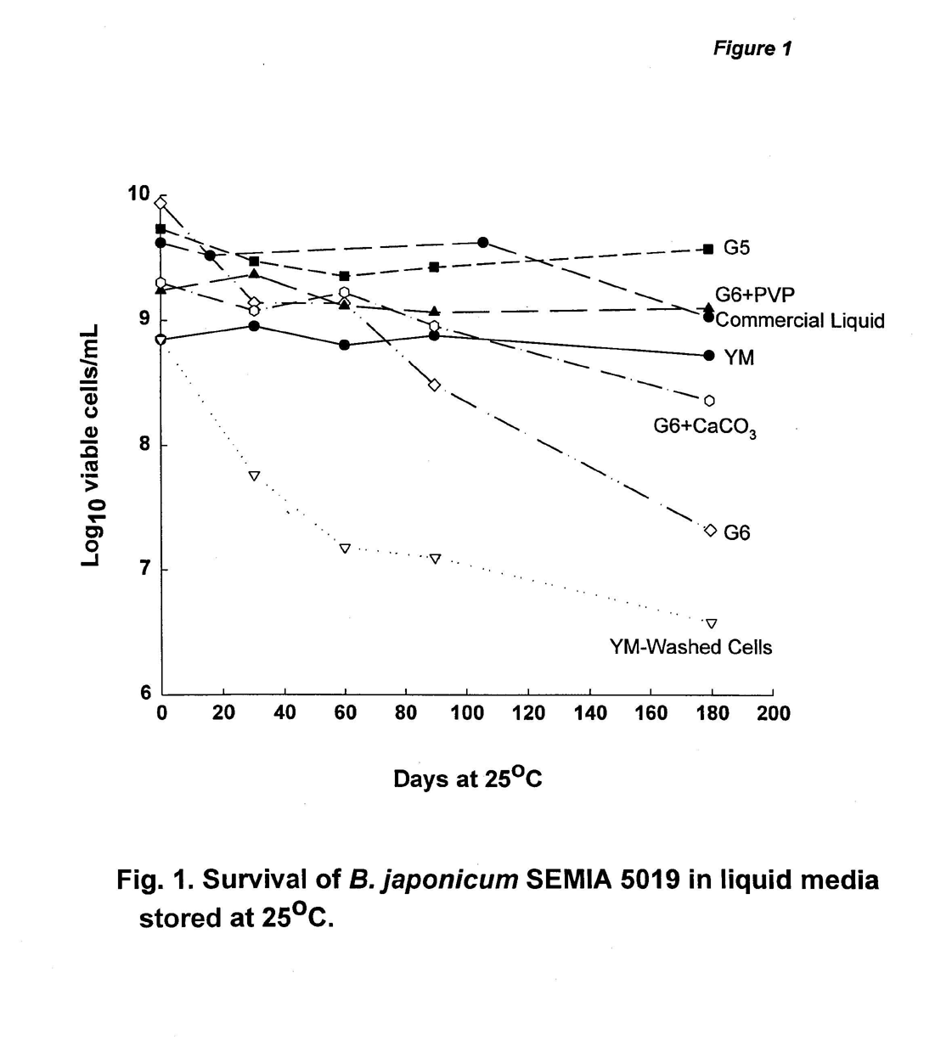

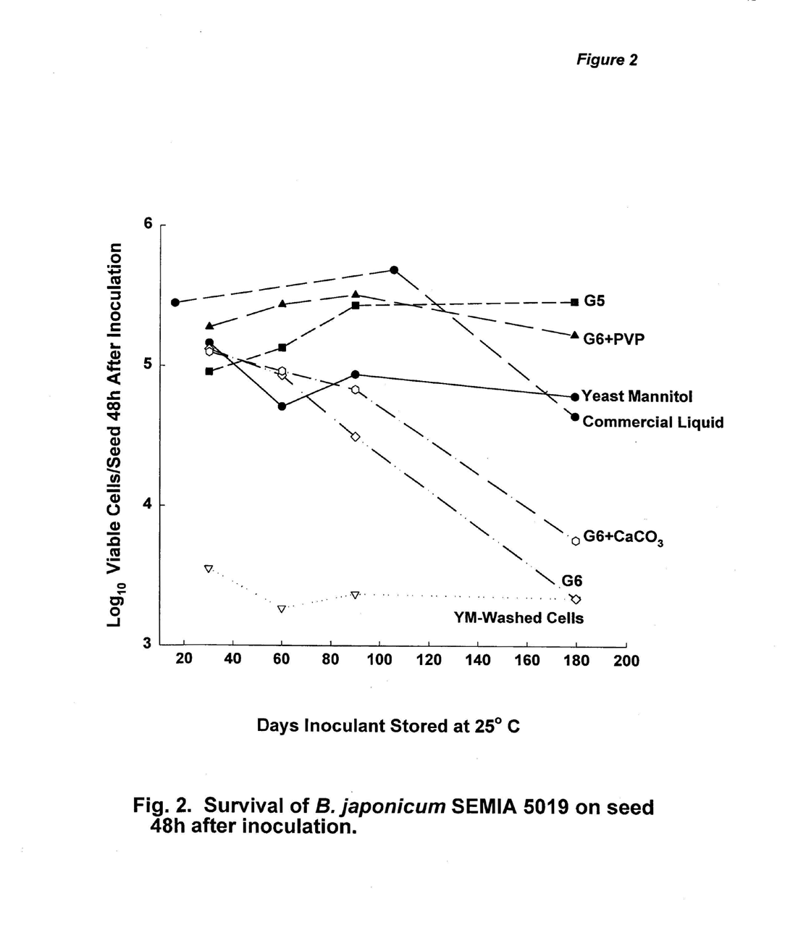

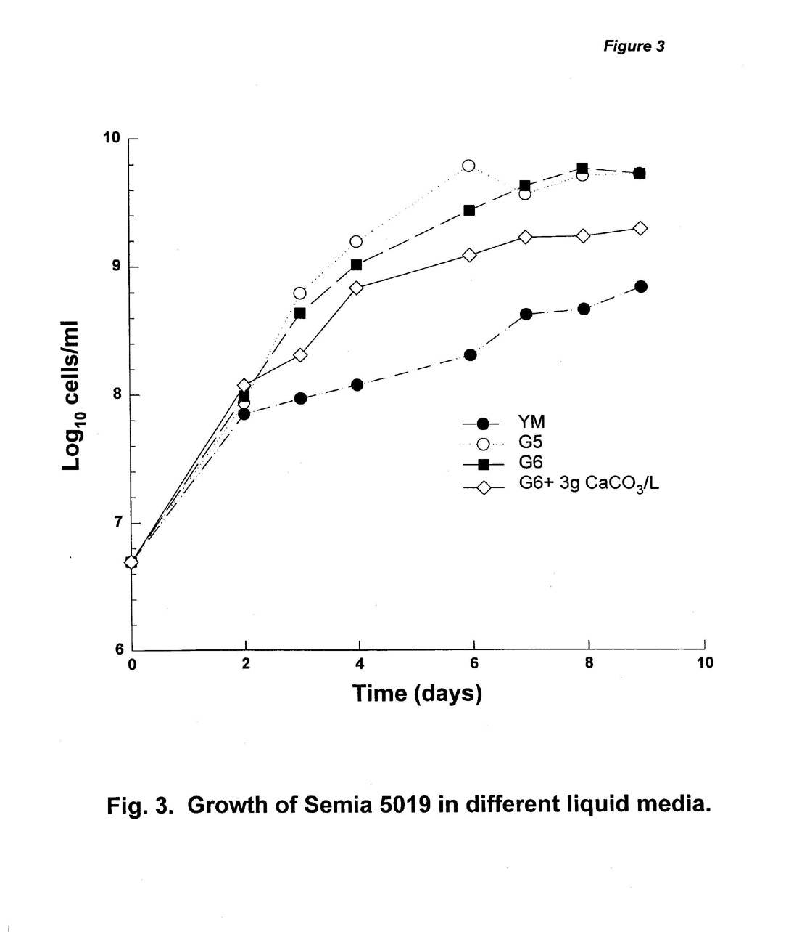

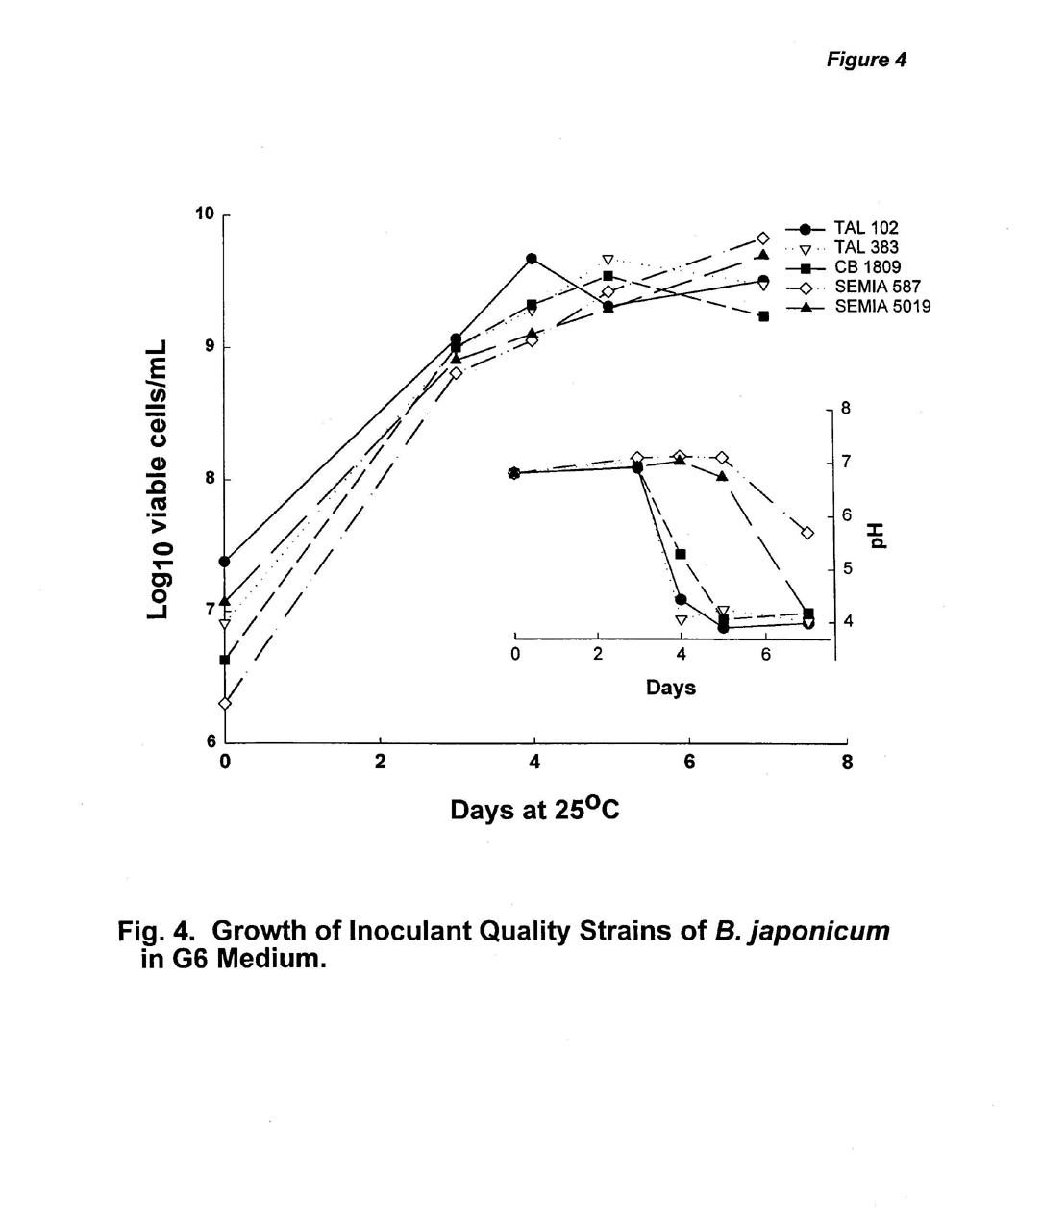

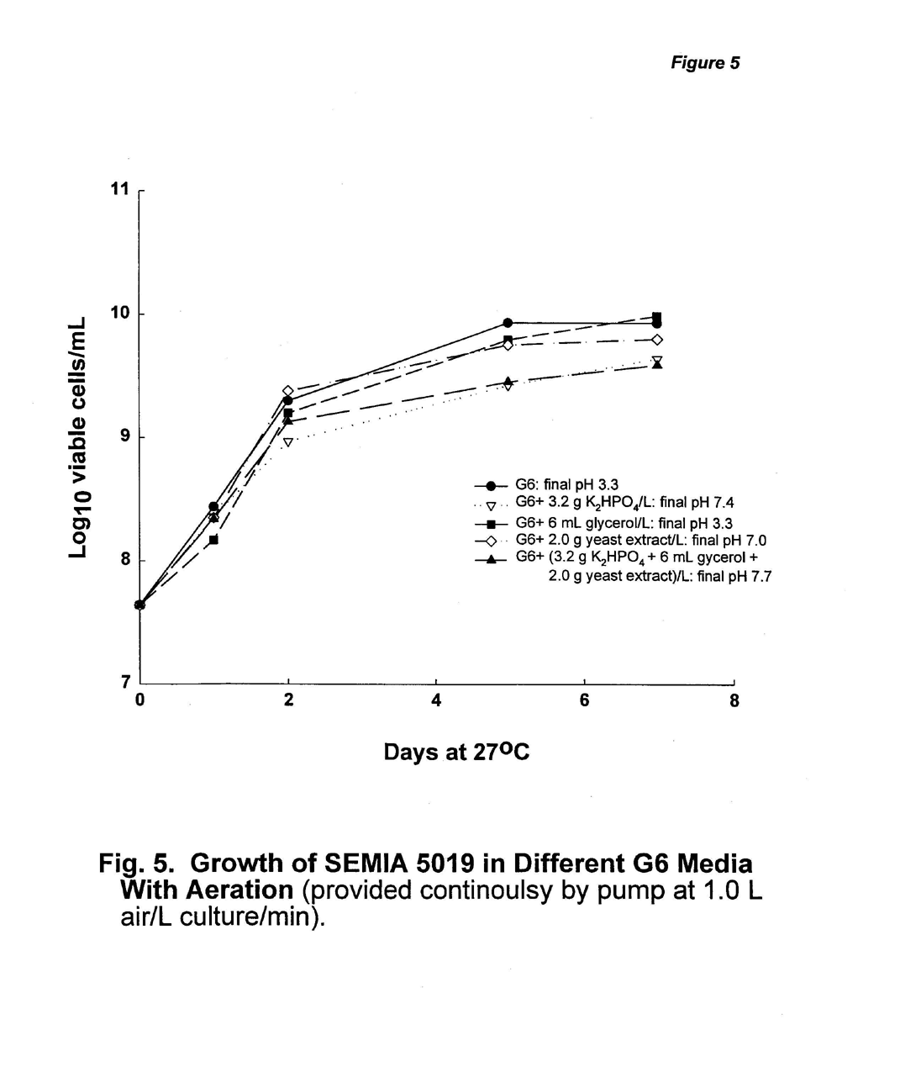

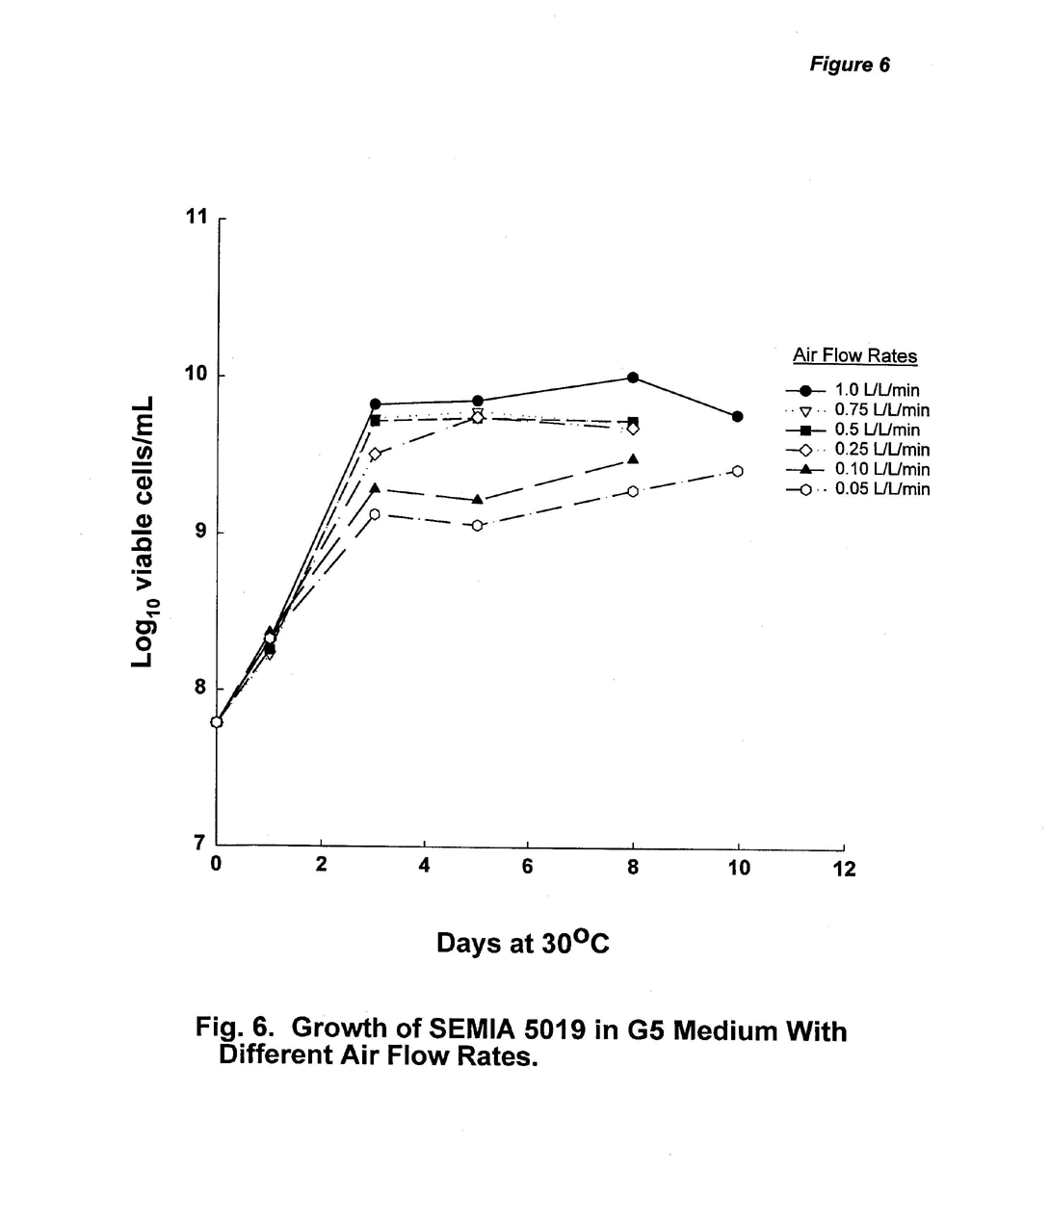

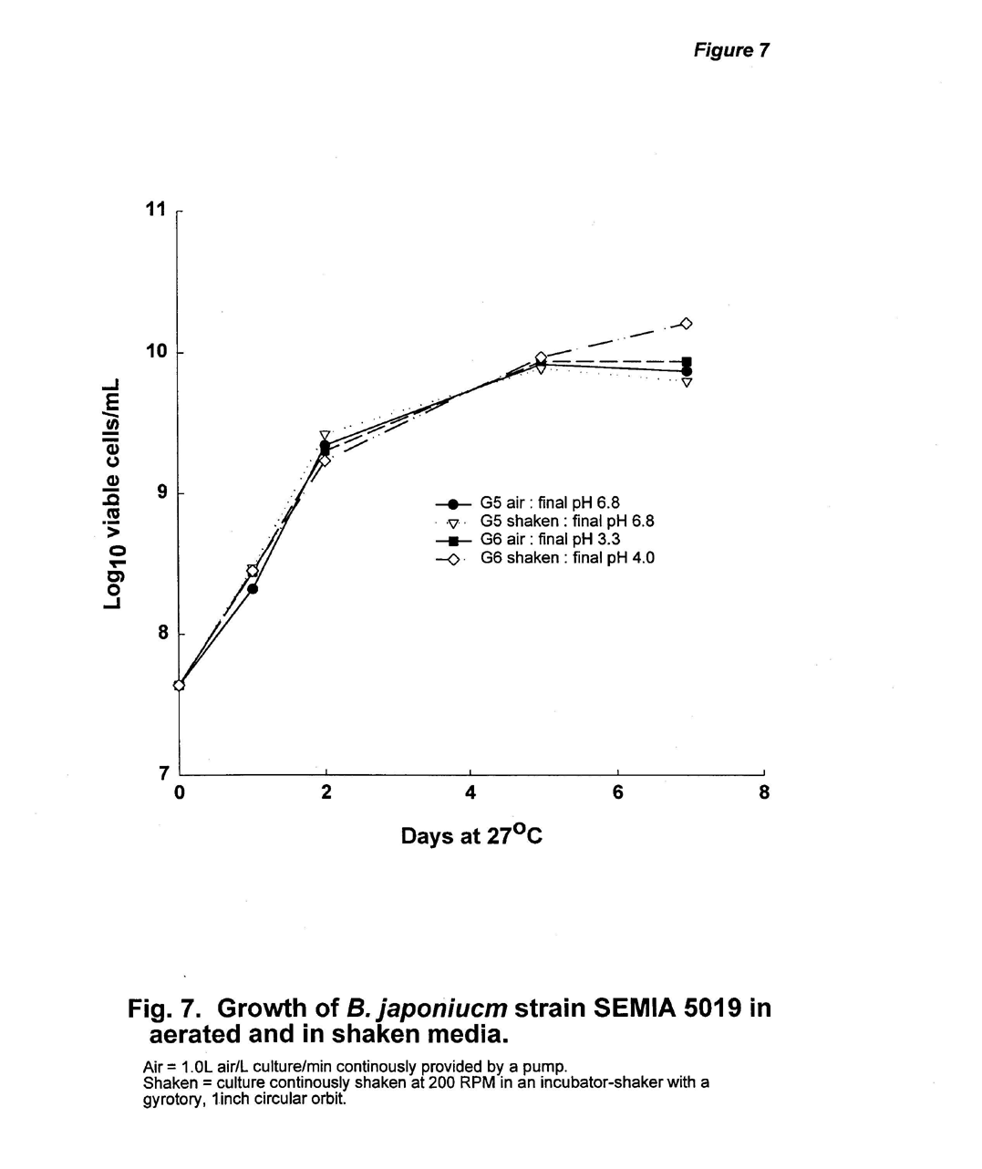

Appendix 1. List of Collaborators

First name | Last name | Department | Institution | Street Address | City/State |  | Zip Code | Country | email | Tel | Fax
Dr. Nantakorn | Boonkerd | Department of Agriculture Biotechnology | Suranaree University of Technology | 111 University Avenue | Nakon Ratchasima, Muang District |  | 30000 | THAILAND | Nantakon@ccs.sut.ac.th | 66 44 216345 | 66 44 216345
Dr. M.A. | Sattar | Soil Micro.Lab | BINA | P.O. Box 4 | Mymensingh |  | 2202 | Bangladesh | Bina@bdmail.net | 880 91 4047 | 880 91 54091
Dr. M. | Thangaraju | Dept. of Agricultural Microbiology | Tamil Nadu Agriculture University |  | Coimbatore - 3, Tamil Nadu |  | 641003 | India | Kcrk@md2.vsnl.net.in | 91 422 431222 | 91 422 431672
Pronob | Paul | Mennonite Central Committee | MCC-Bangladesh | 1/1 Block A | Mohammadpur, Dhaka |  | 1207 | Bangladesh | Volsmcc@bdmail.net | 880 2 911 0486 | 880-2-815625
Jorge | Salazar | Grainco | Almesa | Apdo. No. 153 | Chinandega |  |  | Nicaragua | Grainco@nicanet.com.ni | 505 341 3367 | 505 341 4709
Dr. M.H. | Mehta | Exec. Direct. | GSFC Ltd. | P.O. Fertilizernagar | Vadodara |  | 391750 | India | Gfsc.edrd@smg.sprintrpg.ems.vsnl.net.in | 265 372451 | 265 372966
Dr. Tigi | Verghis | Non-formal Education Centre | Allahbad Agricultural Institute |  | Allahabad, UP |  | 211007 | INDIA | Nfec@aai.wiprobt.ems.vsnl.net.in | 91 532 696 485
Dr. V.P. | Savalgi | Dept. of Agricultural Microbiology | University of Agricultural Sciences | Krishi Nagar | Dharwad, Karnataka |  | 580005 | India | Root@zrckar08.kar.nic.in | 91 836 348321 ext 219 | 91 836 8349
Ms. Tran | Yen Thao |  | Oil Plant Institute of Vietnam (OPI) | 171-175 Ham Nghi St., Dist I | Ho Chi Minh City |  |  | Viet Nam | Opi.vn@hcm.vnn.vn |  | 84 8 8243528
Dr. Sixto R. | Pascua | College of Agriculture and Forestry | Mariano Marcos State University | Batac | Ilocos Norte |  |  | Philippines | Rlrrc@laoag.amanet.net
Professor Zhang | Xue-Jiang | Soil Microbiology | Oil Crops Research Insitute | Chinese Academy of Agricultural Sciences | Wuhan | 430062 |  | PRC | Ocgil@public.wh.hb.cn | 27 868 27874 | 27 868 16451
Dr. Carlos | Labandera | Laboratorio Microbiogia de Selos e Inoculantes |  | Burgues 3208 | C.P. 11.700 Montevideo |  |  | URUGUAY | Lmscilab@adinet.com.uy | 59 82 234167 | 59 82 238152
Dr. Joshua | Daniel |  | BAIF | Dr. Manibhai Desai Nagar | Warje, Pune | 411029 |  | India | Baif@vsnl.com
Dr. Sushil K. | Sharma |  | National Research Centre for Soybean | Khandwa Road | Indore , Madhya Pradesh | 452001 |  | India | Nrcsoya@x400.nicgw.nic.in |  | 91 731 470520
Dr. Ravi P. | Singh | U.P Seeds of Tarai Development Co. |  | Gumati No. 12, P.O. University | Kanpur | 208024 |  | India |  | 522 570487 | 522 546411
Dr. Gaminis | Seneviratne | BNF Project | Institute of Fundamental Studies | Hantana Road | Kandy |  |  | Sri Lanka | Gaminis@ifs.ac.lk | 94 8 232002 | 94 8 232131
Dr. S.C. | Prabhu |  | MAHYCO | Post Box No. 27,B-4, Industrial Estate | Jalna 431 203 |  |  | India | Scprabhu@mayhco.com | 91 2482 30840 | 91 2482 30695
Dr. Juan Carlos | Rosas |  | Escuela Agricola Panamericana | P.O. Box 93 | Tegucigalpa |  |  | Honduras | Eapagrp@ns.hondunet.net | 504 76 6140 | 504 76 6249
Voltan | Senekal |  | Soygro LTD | P.O. Box 5311 | Kockspark 2523, Potchefstroom |  |  | Rep. South Africa | Soygro@potch.lia.net | 148 292 1907 | 148 292 1056
Dr. P.A. | Ndakidemi |  | Selian Research | P.O. Box 6024 | Arusha |  |  | Tanzania |  | 255 057 2268 | 255 057 8557
Dr. Mary | Silver | Soil Science Department | Makerere University | P.O. Box 7062 | Kampala |  |  | Uganda |  | 256 41 542 277 | 256 41 543 382
Dr. Nancy | Karanja | Soil Science Department | University of Nairobi | P.O. Box 29053 | Nairobi |  |  | Kenya | biofix@arcc.or.ke
Dr. Michael | Nyika | Soil Productivity Lab | Grasslands Research Institute | P.B. 3757 | Marondera |  |  | Zimbabwe |  |  | 263 793 871
Dr. B. | Cassien |  | ISAR | BP 138 | Butare |  |  | Rwanda |  |  | 250 30 228
Dr. R.N. | Soni | Chief Manager for R&D | Krishak Bharati Cooperative Ltd. |  | Surat, Gujarat |  |  | India |  | 91 261 722 031 | 91 261 620 038
Mr. Nguyen Xuan | Hong | Faculty of Biology, | Vietnam National University | 334 Rd. Thanh Xuan | Hanoi | 10203 |  | Vietnam | lehung@bio-hu.ac.vn | 84 4 858 3440 | 84 4 858 3061
Dr. Pham Van | Toan |  | Vietnam Agricultural Science Institute | Vandien, Thanhtri | Hanoi | 10650 |  | Vietnam | pvtoan@hn.vnn.vn | 84 4 8615557 | 84 4 8613937
Seed Yield Response to Inoculation with G5 Liquid Inoculant Formulation and Local Inoculant Products Appendix 2-1

Response to NifTAL Relative Response
NifTAL Local Inoculant above: above:
Site Control Liquid Inoculant Control Local Inoc. Control Local Inoc. Remarks
kg/ha kg/ha kg/ha kg/ha kg/ha % %
1a 810 1405 1465 595* -60 73 -4 Cultivar used in sites 1a-1d had
1b 1403 1632 1655 229 -23 16 -1 nodulation problems with SEMIA
1c 743 1141 1276 398* -135 54 -11 used in the G5 formula. This
1d 740 1820 1893 1080* -73 146 -4 is a chorosis producing symbiosis.
2b 1340 1800 2040 460* -240 34 -12
2c 540 1260 1300 720* -40 133 -3 Experiments at sites 2a-2h
2d 960 1540 1260 580* 280* 60 22 conducted on two cultivars and
2e 470 2800 2120 2330* 680* 496 32 with two different strains in
2f 730 2040 1790 1310* 250 179 14 liquid and local inoculant carrier.
2g 1080 1910 1930 830* -20 77 -1 Sites with ' indicate USDA 110
2h 1130 2030 1940 900* 90 80 5 was used; other sites used SEMIA
2b' 1340 2370 2200 1030* 170 77 8
2c' 540 1240 1580 700* -340* 130 -22
2d' 960 1330 1240 370* 90 39 7
2e' 470 2510 2510 2040 0 434 0
2f' 730 2080 2040 1350* 40 185 2
2g' 1080 2140 1900 1060* 240 98 13
2h' 1130 2130 2080 1000* 50 88 2
8a 1726 1946 1905 220 41 13 2
9a 1360 1466 1589 106 -123 8 -8
9b 2499 2380 2311 -119 69 -5 3
10 2451 3088 3051 637 37 26 1
11
14 2102 2172 2224 70 -52 3 -2
14' 2102 2641 2224 539 417 26 19 14' used G5 as a in furrow application
15a 2719 3964 4362 1245 -398 46 -9 No Stats Available-Steam sterilzed peat
17a 944 1210 1063 266* 147 28 14
17a' 944 1210 892 266* 318* 28 36
18a 526 1352 1179 826* 173* 157 15
18b 1152 2329 2187 1177* 142 102 6
18c 887 2019 1950 1132* 69 128 4
18d 466 1059 1066 593* -7 127 -1
18e 1855 2533 2533 678 0 37 0
19a 929 1095 954 166 141 18 15
19b 874 1132 1076 258 56 30 5
19c 1496 1788 1933 292 -145 20 -8
20a 238 666 409 428* 257* 180 63
20b 1665 3119 3057 1454* 62 87 2
20c 1821 3692 3033 1871* 659 103 22
21a 2735 4182 4232 1447 -50 53 -1
21b 3580 4292 4155 712 137 20 3
21c 2298 3142 2607 844 535 37 21
Mean 1306 2089 2005 783 84 90 6

Nodule Number Response to Inoculation with G5 Liquid Inoculant Formulation and Local Inoculant Products Appendix 2-2

Response to NifTAL Relative Response
NifTAL Local Inoculant above: above:
Site Control Liquid Inoculant Control Local Inoc. Control Local Inoc. Remarks
no/ha no/ha no/ha no/ha no/ha % %
(x106) (x106) (x106) (x106) (x106)
2a 2.200 10.200 7.700 8.000* 2.500* 364 32 Sites 2a-2h gave nodule/plant
2b 1.700 8.700 7.400 7.000* 1.300 412 18 data. Assuming 400,000 plants
2c 0.000 5.900 4.900 5.900* 1.000* not defined 20 in harvest area.
2d 0.200 5.600 2.900 5.400* 2.700* 2700 93 Experiments at sites 2a-2h
2e 0.032 4.232 2.632 4.200* 1.600* 13125 61 conducted on two cultivars and
2f 0.468 4.600 2.932 4.132* 1.668* 883 57 with two different strains in
2g 1.500 5.400 6.400 3.900* -1.000 260 -16 liquid and local inoculant carrier.
2h 2.100 4.100 7.000 2.000 -2.900* 95 -41 Sites with " indicate USDA 110
2a' 2.200 9.500 6.500 7.300* 3.000* 332 46 was used; other sites used
2b' 1.700 6.600 6.200 4.900* 0.400 288 6 SEMIA.
2c' 0.000 5.200 4.500 5.200* 0.700 not defined 16
2d' 0.200 4.600 3.300 4.400* 1.300* 2200 39
2e' 0.032 4.632 4.032 4.600* 0.600 14375 15
2f' 0.468 4.900 3.368 4.432* 1.532* 947 45
2g' 1.500 5.800 4.700 4.300* 1.100 287 23
2h' 2.100 7.700 4.400 5.600* 3.300* 267 75
8a 5.330 6.710 5.360 1.380 1.350 26 25
9a 4.230 5.610 3.430 1.380 2.180* 33 64
9b 3.030 2.470 2.870 -0.560 -0.400 -18 -14
10 11.297 12.565 13.655 1.268 -1.090 11 -8
15a 0.000 5.347 6.319 5.347 -0.972 not defined -15 No Stats-sterle Australian peat
17b 0.363 6.000 6.220 5.637* -0.220 1551 -4
17c 0.303 5.960 7.670 5.657* -1.710 1865 -22
17b' 0.363 6.000 5.630 5.637* 0.370 1553 7
17c' 0.303 5.960 6.530 5.657* -0.570 1867 -9
18a 0.000 16.400 15.400 16.400* 1.000 16399900 6
18b 0.000 20.200 17.800 20.200* 2.400 20199900 13
18c 0.000 17.800 16.400 17.800* 1.400 17799900 9
18d 0.000 20.600 18.150 20.600* 2.450 20599900 13
18e 0.000 22.200 19.750 22.200* 2.450 22199900 12
19a 3.940 5.590 5.410 1.650 0.180 42 3
19b 0.220 8.670 7.220 8.450* 1.450 3841 20
19c 0.250 6.600 5.320 6.350* 1.280 2540 24
20a 0.000 2.560 1.690 2.560* 0.870 2559900 51
20b 0.000 12.130 11.810 12.130* 0.320 12129900 3
20c 0.000 8.380 4.190 8.380* 4.190* 8379900 100
21a 0.000 1.410 2.330 1.410* -0.920 14099900 -39
21b 1.560 5.310 4.170 3.750 1.140 240 27
21c 2.100 14.570 14.050 12.470* 0.520 594 4
26 2.780 15.540 2.710 12.760* 12.830* 459 473
26' 2.780 15.540 23.970 12.760* -8.430* 459 -35 Local- sterile Canadian peat w/5019
Mean 1.348 8.483 7.486 7.135 0.997 3537387 29.264

Nodule Weight Response to Inoculation with G5 Liquid Inoculant Formulation and Local Inoculant Products Appendix 2-3 Response to NifTAL Relative Response
NifTAL Local Inoculant above: above:
Site Control Liquid Inoculant Control Local Inoc. Control Local Inoc. Remarks
kg/ha kg/ha kg/ha kg/ha kg/ha % %
1a 25 62 87 36* -26 144 -29 Cultivar used in sites 1a-1d had
1b 56 71 72 16* -1 28 -2 nodulation problems with SEMIA
1c 12 127 113 115* 14 957 13 used in the G5 formula. This
1d 26 79 79 53* 0 200 0 is a chorosis producing symbiosis.
2a 12 39 51 28* -12 238 -23
2b 6 34 27 29* 7 506 27
2c 0 89 82 89* 7 not defined 9 Experiments at sites 2a-2h
2d 0 88 59 87* 29* 25942 49 conducted on two cultivars and
2e 0 24 41 24* -17* 5463 -42 with two different strains in
2f 10 47 35 37* 12 389 33 liquid and local inoculant carrier.
2g 25 96 85 71* 11 287 13 Sites with " indicate USDA 110
2h 30 68 70 38* -2 127 -3 was used; other sites used SEMIA
2a' 12 36 53 24* -18* 206 -33
2b' 6 36 29 30* 7 534 25
2c' 0 85 79 85* 6 not defined 7
2d' 0 59 56 59* 3 17430 4
2e' 0 51 46 51* 6 11775 12
2f' 10 30 33 21* -3 217 -9
2g' 25 70 57 45* 13 183 22
2h' 30 46 59 16 -13 53 -22
8a 37 52 42 16* 10* 42 24
9a 40 51 42 11 9 28 21
9b 27 26 25 -1 1 -4 4
10 70 82 79 11 3 16 4
14 3 5 15 2 -10* 59 -64
14' 3 6 15 2 -10 62 -64 14' used G5 as an in furrow application
17b 5 80 70 74* 9 1402 13
17c 13 134 94 122* 40 957 43
17b' 5 80 93 74* -14 1402 -15
17c' 13 134 99 122* 36 957 36
18a 0 106 94 106* 12 105999900 13
18b 0 120 107 119* 13 119499900 12
18c 0 114 99 113* 15* 113499900 15
18d 0 108 94 108* 14 107999900 15
18e 0 152 132 152* 20 151999900 15
19a 21 29 27 8 1 38 4
19b 1 46 36 44* 9 3037 26
19c 0 32 28 32* 4 10699900 16
20a 0 25 15 25* 10* 25299900 66
20b 0 157 74 157* 83* 156899900 111
20c 0 205 179 205* 26 204599900 14
21a 0 1 2 1 -1 1409900 -39
21b 2 5 4 4 1 240 27
21c 2 15 14 12 1 594 4
26 15 82 19 66* 62 429 323
26' 15 82 113 67* -31 447 -27 Local is Sterile Canadian peat
Mean 12 69 61 57 7 22681441 14

Seed Nitrogen Response to Inoculation with G5 Liquid Inoculant Formulation and Local Inoculant Products Appendix 2-4

Response to NifTAL Relative Response
NifTAL Local Inoculant above: above:
Site Control Liquid Inoculant Control Local Inoc. Control Local Inoc. Remarks
kgN/ha kgN/ha kgN/ha kgN/ha kgN/ha % %
1a 46.8 86.9 87.0 40* 0 86 0 Cultivar used in sites 1a-1d had
1b 68.7 78.0 78.0 9* 0 14 0 nodulation problems with SEMIA
1c 41.9 59.9 67.9 18* -8 43 -12 used in the G5 formula. This
1d 39.4 93.5 101.5 54* -8* 137 -8 is a chorosis producing symbiosis.
2b 76.1 104.2 108.5 28* -4 37 -4
2c 23.5 167.9 136.4 144* 32* 615 23 Experiments at sites 2a-2h
2d 36.6 122.0 98.9 85* 23* 234 23 conducted on two cultivars and
2e 26.1 60.5 67.6 34* -7 132 -11 with two different strains in
2f 40.7 78.7 55.3 38* 23* 93 42 liquid and local inoculant carrier.
2g 63.8 127.8 118.5 64* 9 100 8 Sites with " indicate USDA 110
2h 72.9 127.0 122.6 54* 4 74 4 was used; other sites used SEMIA
2b' 76.1 149.0 142.0 73* 7 96 5
2c' 23.5 129.3 136.9 106* -8 451 -6
2d' 36.6 125.1 127.9 89* -3 242 -2
2e' 26.1 61.9 78.8 36* -17* 137 -21
2f' 40.7 59.0 65.5 18* -7 45 -10
2g' 63.8 119.1 121.2 55* -2 87 -2
2h' 72.9 134.9 144.8 62* -10 85 -7
8a 87.9 95.6 93.6 8 2 9 2
9a 80.9 87.2 90.1 6 -3 8 -3
9b 149.5 141.2 136.4 -8 5 -6 4
17a 44.7 65.2 57.8 21* 7 46 13
17a' 44.7 65.2 57.6 21* 8 46 13
19a 66.2 81.3 72.7 15 9 23 12
19b 52.5 79.9 72.4 27 8 52 10
19c 101.7 124.5 134.2 23 -10 22 -7

Mean 58 101 99 43 2 112 3

Appendix 3-1

Laboratory Assay for Testing Inoculant Survival on Seed: Materials and Methods

BACKGROUND:

To evaluate formulations or their components, a rapid laboratory assay was needed that provided an indication of how well an inoculant will perform after application to seed. We evaluated survival of B. japonicum after seed inoculation with various formulations (strains, additives, commercial formulations etc.) under standard laboratory conditions (68% relative humidity and 26º C). We then correlated survival in the laboratory assay with performance in potted soil in the greenhouse. A stress period was imposed on the inoculant by leaving the soil dry for 48 h after planting. The soil at seed level consistently reached maximums of 45-48º C during this period.
Table 1 shows that survival of B. japonicum on seed under laboratory conditions was a reasonable indicator of inoculant performance on soybean planted in dry soil at high temperatures.

Table 1. Correlation between number of B. japonicum cells surviving on soybean
seed in the laboratory at 26º C and 68% R.H. and nodulation and growth
of soybean planted into dry potted soil.
Time from inoculation (h) | Nodule Dry  Weight | Shoot Dry  Weight
 | R
0 | 0.72* | 0 .70
2 | 0.76* | 0.70
4 | 0.92*** | 0.84**
24 | 0.83** | 0.76*
48 | 0.86** | 0.77*
*** P<.01; ** .05>P>.01; *.1> P >.05; Pots irrigated 48 h after planting; Pots reached maximum temperatures
of 48ºC for 2 d before irrigation and 38 C for next 7 d; harvest 33 DAP

PROCEDURE:

A liquid culture of Bradyrhizobium japonicum SEMIA 5019 in late log phase was used to inoculate seed. Williams soybean seed were inoculated in batches of 120 seeds with 60 µL liquid inoculant or 0.06 g peat. Peat inoculated seeds were pre-coated w/ 75 µL gum arabic sticker solution (40 g gum arabic in 100 mL H₂O, heated in microwave). Seeds were coated in sterile 50 mL beakers with a glass stir rod. Immediately following inoculation seeds were poured into Petri dishes which were then placed in sealed containers above saturated CuCl_{2.}2H₂O solution in a 26º C incubator, yielding 68% RH and a seed moisture content of 0.13 g H₂O/g seed. At 48h after inoculation, seed were removed from the incubator and poured into a 250 flask containing 120 mL sterile diluent (0.85% NaCl, 0.01% Tween 80). The flask was shaken for 5 min on a Burrell wrist action shaker set at maximum speed, followed by 5 min of ultrasound exposure in a Bronson ultrasonic cleaner containing water up to the level of diluent.

Three steps of serial, ten-fold dilutions in saline diluent were prepared, with 100 µL aliquots from each of the 10⁻¹ to 10⁻³ dilutions spread on G6 agar plates. The plates were incubated at 28ºC for 5-7 days, and plates with 30-300 colonies were chosen for counting.

Notes:
- Samples should be replicated, and duplicate plate counts made from a given dilution level.
- YM, AG or other suitable media can be substituted for G6 in the inoculant broth or agar media. In our experience the G6 medium supports the most rapid growth.

Appendix 3-2

Laboratory Assay for Testing Shelf Life of Liquid Inoculants:
Materials and Methods

Bradyrhizobia strain. SEMIA 5019 was used in all media. The sources for inoculation into media were early stationary phase cultures (population densities >10⁹ cells/mL) of YM, G5, G6 or G6+3g CaCO₃/L. Samples from these sources were used undiluted or diluted, as described below.

Treatments. Different media were evaluated for ability to sustain high densities of viable cells over a 180 day period at a constant temperature of 25ºC. The media tested were the following:

- YM undiluted.
- YM cells washed (shaking + centrifugation) 3 times in saline, final re-suspension in distilled water.
- G5 undiluted.
- G6 undiluted.
- G6 diluted 1:5 in 25g PVP/L.
- G6 diluted 1:5 in 15mL glycerol/L
- G6 diluted 1:5 in 400uM Fe-EDTA
- G6 diluted 1:5 in 25g PVP/L + 15mL glycerol/L + 400uM Fe-EDTA.
- G6+3g CaCO₃/L undiluted.
- Commercial liquid undiluted.

Experimental units consisted of 100 mL volume in a 250 mL flask fitted with a foam stopper (for air exchange). Dilutions were prepared by addition of 20 mL of the inocula source to 80 mL of the sterile diluent. All diluents were prepared with deionized water. Treatments consisted of five replicates.

Storage Conditions. Treatments were kept in a gravity convection incubator at a constant temperature of 25ºC. Humidity was not controlled.

Sampling. Two replicates of each treatment were sampled for viable population density and survival on seed (see Appendix 3-1) for 48h at 30, 60, 90 and 180 days after placement in the incubator, using G6 agar medium. The commercial liquid inoculant treatment was added after initiation of the experiment, and was sampled at 16, 106 and 180 days after incubation.

Appendix 3-2
Description of Aerated Fermentor Vessels.

The fermentor set up consisted of a 2.0 L boro-silicate screw top bottle (Corning brand) containing 1.5 L of liquid media. Each 2.0 L bottle was connected to the same style 250 mL bottle by silicone tubing. The second bottle was a reservoir for any foam generated by the culture that filled the head space of the 2.0 L bottle.

The centers of the both bottles’ plastic screw caps were drilled out. An 8.0 mm thick silicone gasket with two holes was fit to the inside of each bottle cap. One hole in the silicone gasket of the 2.0 L bottle was fit with a 7 mm i.d. polypropylene air sparger tube that extended to 2 cm of the bottom, of the bottle. A flexible silicone tube connected the sparger tube to a 0.2 uM Millipore filter that sterilized air entering the 2.0 L vessel. The other hole in the gasket of the 2.0 L bottle was fit with a 7 mm i.d. silicone tube (flush with the gasket surface) that also connected to the gasket of the 250 mL bottle. Air exited the 250 mL bottle through another silicone tube that terminated in a 50 mL plastic syringe body filled with two foam plugs.

The fermentor assemblies were connected to an air delivery manifold via a brass needle valve to control air flow. Air flow was monitored at the air outlet of each assembly with a glass tube air flow meter. Back pressure in the air manifold was maintained at 2.0 psi. Assemblies were placed on a heat mat with a the thermocouple of the controller placed into a dummy vessel that was also aerated. Temperatures were monitored with a thermocouple pressed against the glass of the 2.0 L vessel with a 10 mm thick piece of latex rubber. Temperatures measured this way were within 0.2 C of temperatures measured by immersing the thermocouple into the liquid.

Each 2.0 L vessel had an 18 mm dia. hole drilled into the side and near the bottom of the vessel to accommodate a tapered (17 mm dia at the small end) red rubber septum. The septum port was used for sterile sampling of the media.

Appendix 3-4
Formulation of several liquid media.(g L⁻¹ unless otherwise stated)
 | YMB* | G1 | G2 | G4 | G5 | G6+ pvp
Mannitol | 1.0 | 10.0 | 1.0 | 1.0 | 1.0
K₂HPO₄ | 0.5 | 0.5 | 0.5 | 0.5 | 0.5 | 0.8
MgSO₄7H₂O | 0.2 | 0.2 | 0.2 | 0.2 | 0.2 | 0.5
NaCl | 0.1 | 0.1 | 0.1 | 0.1 | 0.1 | 0.1
Yeast extract | 0.5 | 1.0 | 1.0 | 1.0 | 1.0 | 2.0
Glucose |  | 1.0 | 1.0 | 1.0 | 1.0
Arabinose |  |  | 1.0 | 0.5 | 0.5
PVP-40** |  | 20.0 | 20.0 | 20.0 | 20.0 | 20.0
Trehalose |  | 10 mM | 2mM
FeEDTA |  | 200µM | 200µM | 400µM | 200µM
CaCl₂ |  |  |  |  |  | 0.14
FeCl₃ |  |  |  |  |  | 8.4mg***
NH₄Cl |  |  |  |  |  | 0.6
NaOH |  |  |  |  |  | 0.16****
Glycerol |  | 1.0 mL | 1.0 mL | 4.0 mL | 4.0 mL | 12.0 mL

* Controls in this work used YMB media modified from Vincent, 1970 by incorporating 1 g/L mannitol rather than 10 g/L. ** PVP av. mol. wt. = 40,000, K value (viscosity) = 26-35. Add the pvp last and shake or agitate media viigorously to dissolve. PVP can cause foaming when forced air is used to aerate culture. ***Add 8.4 mL of a stock solution containing 1.0 g FeCl₃ L⁻¹. **** Add 4.0 mL of a 1.0 M NaOH stock solution (40 g NaOH L⁻¹) . The final pH will be approximately 6.8

Appendix 3-5

Laboratory Assay for Evaluation of Gums to Increase Efficacy of
Liquid Inoculants: Materials and Methods

Bradyrhizobia strain. SEMIA 5019 was used in all media. The source for inoculation into the gum media was an early stationary phase culture in G6 medium. An early stationary phase culture in G5 medium that was used only as a control for comparison with the gum media inoculated with the G6 culture.

Treatments. Different natural gums were evaluated for their ability to promoted short term suvival of inoculant and survival on seed after 48h. The treatments included:

- G5 undiluted
- G6 diluted 1:1 in deionized water
- G6 diluted 1:1 in xanthan gum
- G6 diluted 1:1 in guar gum
- G6 diluted 1:1 in locust gum
- G6 diluted 1:1 in karaya gum
- G6 diluted 1:1 in ghatti gum
- G6 diluted 1:1 in tragacanth gum
- G6 diluted 1:1 in carrageenum gum

Experimental units consisted of 50 mL volume in a 100 mL flask fitted with a foam stopper. dilutions were prepared by addition of 25 mL of the G6 inocula into 25 ml of gum diluent. All gums were prepared by mixing 8g/L deionized water and sterilized by autoclaving – hence, final concentration of all gums was 4g/L. Treatments were prepared in duplicate.

Storage conditions. Treatments were kept in a gravity convection incubator at a constant temperature of 25ºC. Humidity was not controlled.

Sampling. Both replicates were sampled at 9 days after incubation for viable population density and survival on seed (see Appendix 3-1) for 48h. G6 agar medium was used for these determinations.

Appendix 3-6

Quality Control of Collaborators’ Inoculants: Materials and Methods

1. INOCULANT POPULATION DENSITY

Upon receipt, collaborator's inoculants were placed in a refrigerator (4C) and stored there until sampled. Inoculants, which were friable, were mixed thoroughly by hand; the surface of the bag was wiped with ethanol, and sliced open with a flame-sterilized scalpel. A 10.0g sample was obtained with a flame-sterilized spatula and placed on sterilized weigh paper on a scale. The scale was on a clean tabletop exposed to the ambient air of the laboratory. Our experience with this procedure makes us confident that very few if any contaminants are introduced during this brief exposure to non-sterile air.

The sample was then transferred with the aid of a sterile-paper funnel to a flask containing 90 ml sterile saline (0. 85 % NaCl). The flask was attached to a wrist action shaker and run at maximum speed for 20 minutes.

In a laminar flow transfer hood, a serial, seven-step, 10-fold dilution series was prepared (the shaken flask sample = 1/10 dilution step) in sterile 9 ml saline in test tubes. Transfers were done with 1.0 ml sterile pipette tips followed by mixing on a tube mixer (vortex mixer), and each tip was wetted and exhausted three times before the 1 ml aliquot for transfer was removed to the next tube.

Dilution steps four through seven were sampled and transferred to yeast-mannitol agar plates (Somasegaran and Hoben) by placing a 1.0 mL aliquot at the center of the plate, followed by thorough spreading with a flame-sterilized glass rod (prepared in the shape of the letter "L”). Duplicate samples were plated from each step. After two hours, the plates were inverted, placed in a plastic bag to prevent dehydration and placed in a 27 C incubator. Plates were checked daily for at least seven days for presence of bradyrhizobia and contaminants. In some cases the presence of fast-growing contaminants limited the choice of dilution steps from which bradyrhizobia could be counted. Where possible, plates with 30-300 putative bradyrhizobia colonies were counted. Putative bradyrhizobia colonies on the highest dilution plates were selected for authentication by inoculation of soybean plants.

2. INOCULANT SURVIVAL ON SEED

Williams soybean seed ('Belts95", USDA, Beltsville MD) were inoculated in batches of 120 seeds with 0.06 g peat. The inoculant sample was obtained as described above. In a laminar flow transfer hood, seeds were pre-coated with 60 uL of sterile deionized water. Seeds were coated in sterile 50 mL beakers with a flame sterilized glass stir rod.

The inoculated seeds were placed in sterile Petri dishes in sealed containers above saturated
CuCl₂.2H₂0 solution in a 25 C incubator, yielding 68% RH and a seed moisture content of 0. 13 g H20/g seed. At 48 h after inoculation, the petri dishes were opened in the hood and the entire contents transferred to a flask containing 120 mL sterile saline. The flask was placed on a wrist action shaker and run at full speed for 5 minutes, followed by bath sonication for 5 mm. A three step, 10-fold serial dilution, sampling to plates, incubation and counting of all three steps in duplicate was carried out as described above.

3. AUHENTICATION OF INOCULANTS

To confirm the putative plate counts of Bradyrhizobium or Rhizobium collaborators' inoculants were tested for authenticity by production of nodules on soybean plants. We used 0.5 g of pure inoculant and single colonies picked from the highest available dilution plates used in the population density assay.

Seed of the appropriate legume host were imbibed with deionized water. Imbibed seed were placed in sterile vermiculite for germination. After 48 h, seed with adequate radicals were selected and placed individually in growth pouches supplied with 30 ml N-free nutrient solution (see Somasegaran and Hoben). Pouches were placed in a growth room equipped with high-pressure sodium grow lights, alternately water with N-free solution and sterile water.

A 10 gram sample of inoculant was placed in 90 ml sterile deionized water. A five mL sample of this 1/10 dilution was inoculated onto four replicate soybean seedlings in pouches. Two to four single colonies from plates of each inoculant were removed with a sterile cotton-tip swab and dispersed into 1.0 mL sterile water, which was then inoculated onto a single soybean seedling.

Plants were evaluated daily after 10 days for the presence of nodules for at least 14 days. Colonies from SEMIA 5019 were used as a positive control, and uninoculated plants served as negative controls, with four replicates each. All positive controls were nodulated, while none of the uninoculated plants had nodules.

